**1-Car models 1990-2018:**

This dataset includes 11915 rows

It has these columns:

Make, Model, Year, Engine type, Engine HP, Engine cylinder, Transmission type, Driven Wheels, Number of doors, Market Category, Vehicle size, Vehicle Style, Highway MPG, City MPG, Price

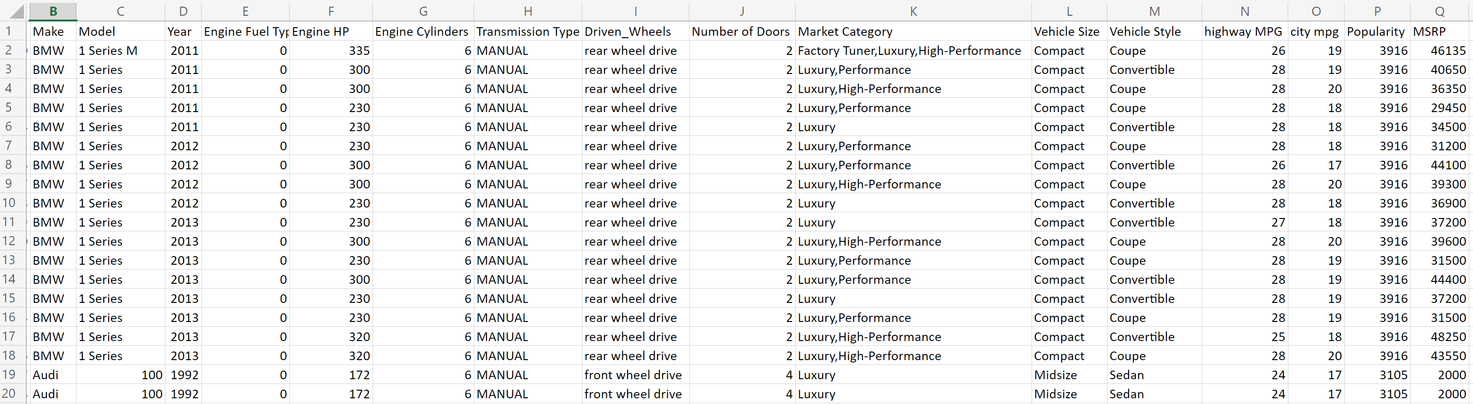**Ideas:**

1-What is the prediction of car price in 2017 and 2018 based on initial features? This project can be modelled according to the data from 1990 to 2016.

2-What is highway MFG of a car in 2017 or 2018 based on initial feature?

**2-Real Estate properties in New York City:**

This dataset includes 84549 rows.

Columns names:

Borough, Neighborhood, Building, Tax class, Block, LOT, Easement, Apt number, Address, Zip code, Residential units, commercial units, Total units, Land Area, Year building, Sale price, Sale date.

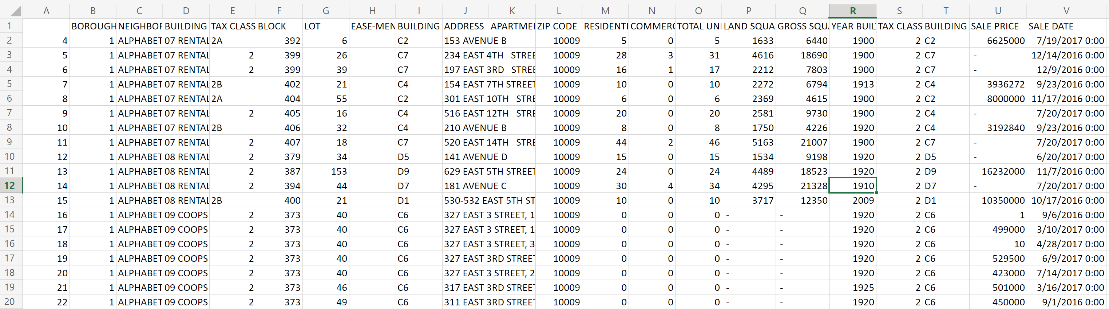**Ideas:**

1-What is the property price for last 5 months of 2017 based on initial features of the property?

**3-Tv serries in Amazon prime:**

This table has 119391 rows.

It has these columns:

Is canceled, Lead time, Arrival date, Aday, stays in weekend night, Adult, Children, Babies, Meal, Country, Market segment, distribution channel, is repeated guest, previous cancelation, previous booking, reserved room type, assigned room type, booking changes, deposit type, agent, company, days in waiting list, customer type, required car parking spaces, total special request, reservation status, reservation status date

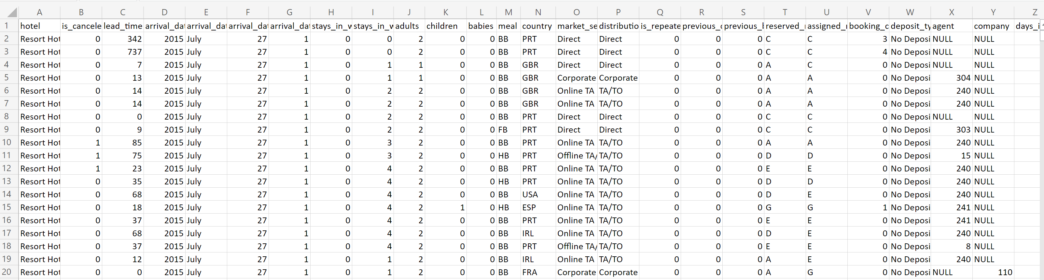

**Idea:**

1-What is number of hotel reservation for last 5 months of year 2017?

2-What is the prediction of cancelation for the last 5 months of year 2017?